The Magic Behind GPTs: How Computers Learn to Talk Like Us

Have you ever wondered how a computer can come up with human-like answers to your questions, as though it's holding a real conversation? It's not magic, but something very clever. You're about to dive into the fascinating world of GPTs - a kind of super-smart language model that's trained to understand and generate text based on what it's learned.

# Learning from Texts

At the heart of GPTs is this basic idea: they learn by reading. Imagine the computer sitting down with a giant stack of books, websites, and conversations--not just a few, but more information than you or I could ever get through! Over time, it starts to recognize patterns, just like we do when we learn to read. It notices which words often come after others, how sentences are formed, and which phrases make sense together.

Picture a young student with piles of books stacked around them, studying hard, with light bulbs popping up over their head as they start to see patterns in the words. This is like GPT learning from all the text it's read!



Now that GPT has learned these patterns, let's look at how it actually uses this knowledge to predict the next word like an expert storyteller.

# The Power of Prediction

Here's where the real magic happens! When you start a conversation with GPT, it doesn't just randomly guess the reply. Instead, it tries to think, 'What word or thought makes the most sense to come next based on all the patterns I've seen?' It's like someone trying to finish your sentence because they're good at identifying what should come next.

Imagine someone at a party who's really great at guessing what someone else is going to say. They hear the start of a sentence and go, 'I bet you're going to say…' and they're almost always right. That's how GPT predicts what words to use!

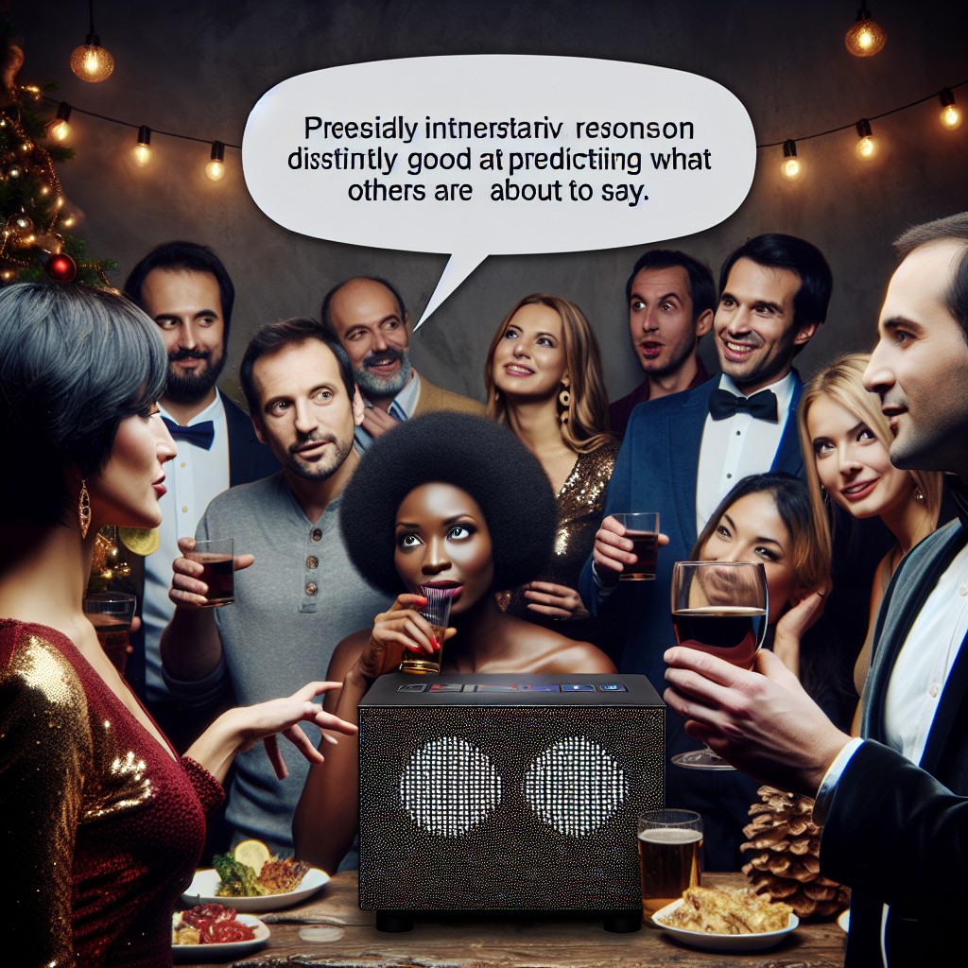

But GPT doesn't just mimic the exact sentences it's seen before, it can come up with new and creative answers that still make sense. Let's explore how.

# Creativity from Connections

One cool thing about GPTs is that they can combine ideas in new ways. Say it's read a fairy tale about dragons, and a space exploration article. It might put these ideas together to tell a story about a dragon flying through space. GPT isn't just limited to what it's seen; it mixes things up to create something fresh, based on the connections it has learned.

Imagine a dragon wearing a space helmet, zooming through the stars. That's GPT taking two different ideas, like dragons and space travel, and weaving them together into something totally new!

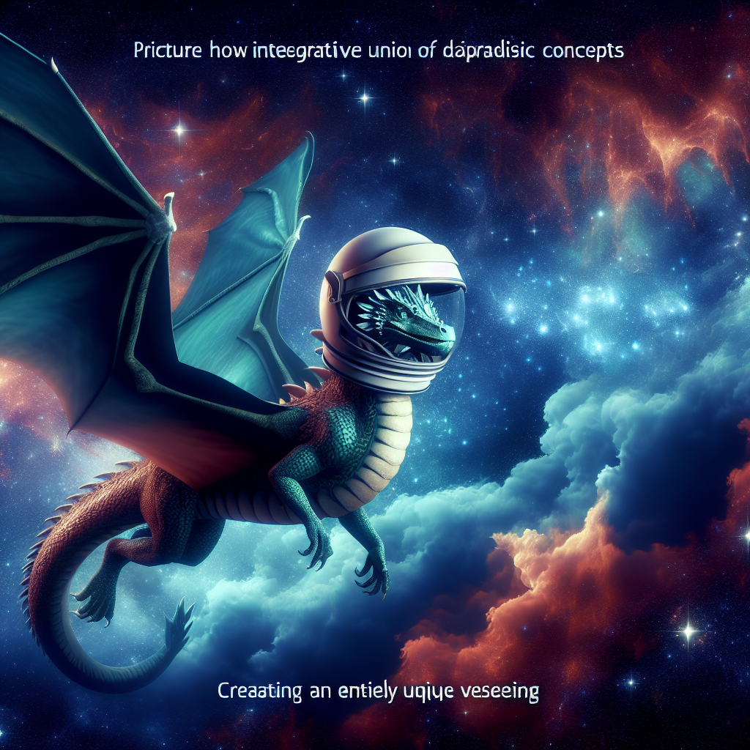

You might wonder, how does it know which ideas to combine or which rules to follow when creating text? Let's dive into its training next.

# Training - The Brain Workout

To get really good at predicting words and making connections, GPT goes through tough training. Think of it like a workout for its brain. Early on, it makes lots of mistakes - like predicting weird words or nonsense - but with each error, its trainers give it feedback: 'Nope, not quite! Try this instead.' Over time, it learns which patterns work and which don't, getting better with every step.

Picture a coach training a runner, correcting their form over and over. At first, it's messy, but after lots of practice, the runner becomes more polished and efficient. This is like GPT learning from its millions of mistakes and improving each time.

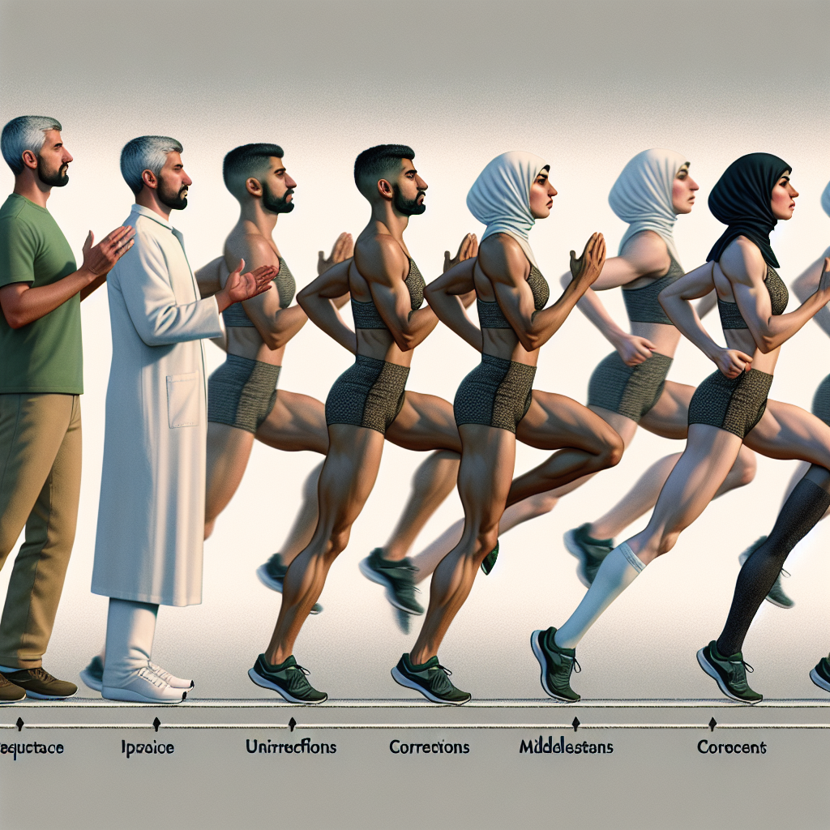

GPT has now learned how to understand, predict, and create text. But how does it keep it all together in such a natural and fluid way when talking to you?

# Flowing Like a Conversation

So, when you ask GPT a question, not only does it predict the next word, but it also tracks everything said so far - building on the conversation as it goes. It tries to keep things on topic and logically connected, making it feel like you're chatting with a person who remembers everything you've said!

Visualize a spider web where each part connects to the other. GPT remembers your earlier questions and responses, tying them all together like the threads of a smooth, ongoing conversation.

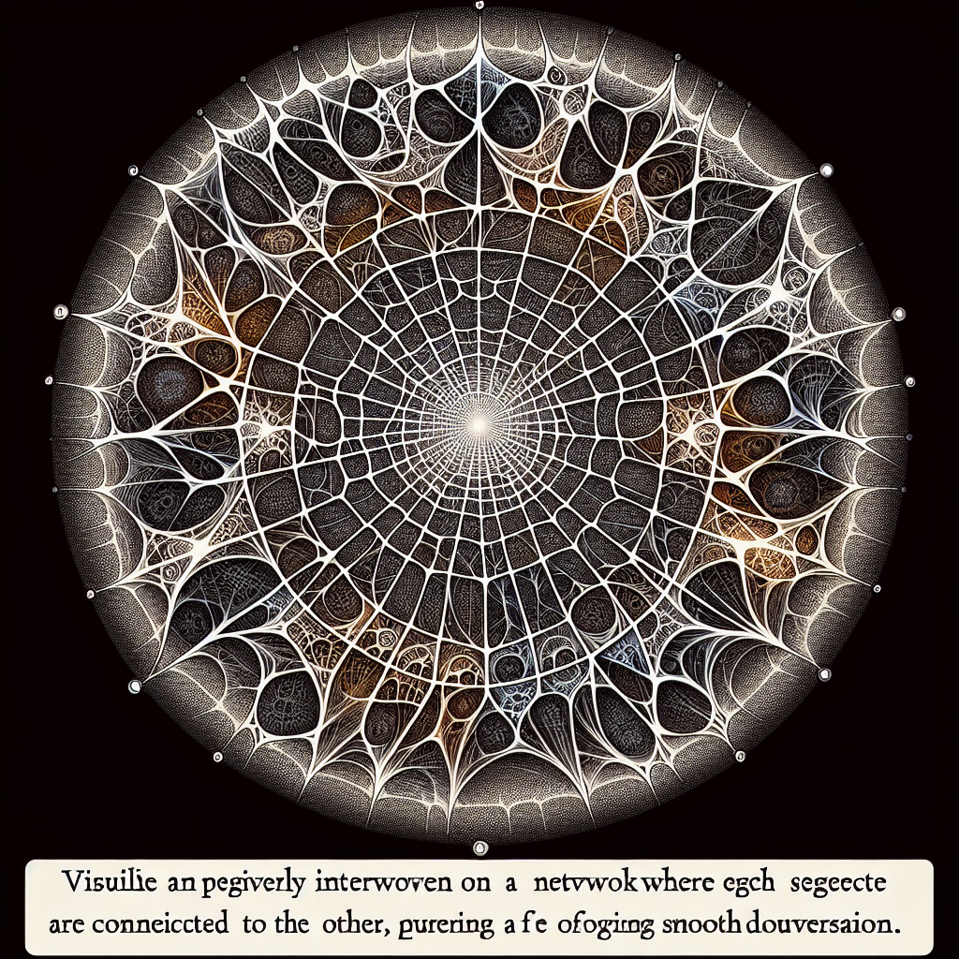

Now that you've seen how GPT learns, predicts, and creates, let's wrap it up with a quick overview of all these steps.

# Conclusion

GPTs are like super-learners: they absorb huge amounts of text, spot patterns, and use this knowledge to predict the next word, create new ideas, and build smooth conversations. Just like a student in training, they get better and better the more they practice. So, next time you chat with a computer, remember - it's that little brain workout it went through that makes it sound so much like a human!